**Introducing ApexaiQ**

**Author:** Apurva Sachin Kulkarni

**Date:** 12th August, 2025

**Introduction**

This document serves as a comprehensive knowledge resource compiled during the first week of my internship at ApexaiQ. It consolidates key information about the company’s platform, the industry problems it addresses, the fundamentals of IT Asset Management (ITAM), competitor analysis, and essential cybersecurity concepts. The purpose of this documentation is to establish a clear understanding of ApexaiQ’s technological capabilities, market positioning, and the broader IT and security landscape in which it operates.

**1. What does ApexaiQ do? What industry problem does it solve?**

**What ApexaiQ Does**

ApexaiQ is a SaaS-based, agentless, continuous IT asset assurance platform that transforms how companies secure and manage their technology environments — from visibility to remediation. It automates the discovery, assessment, and monitoring of all IT assets (on-premise, co-located, and cloud) in near real time, providing:

* **Comprehensive inventory** of all technology assets.
* **ApexaiQ Score** — a risk score similar to a human IQ score that quantifies an organization’s IT environment health.
* **Vulnerability & obsolescence identification** to highlight outdated or risky assets.
* **Gap detection** for missing controls or non-compliance.
* **Granular role-based access control** for sensitive information.
* **Automated reporting** for compliance and cyber insurance needs.
* **Single-view dashboard** for faster decision-making.

The platform eliminates repetitive, manual tasks in asset tracking and vulnerability identification, enabling IT and security teams to focus on core priorities.

**The Industry Problem that ApexaiQ Solves**

**Challenge:** Modern organizations face growing complexity in their IT environments, often spread across multiple locations, cloud platforms, and device types. Traditional IT Asset Management (ITAM) approaches rely on spreadsheets or siloed systems, which are:

* **Error-prone and outdated** — making asset data unreliable.
* **Time-consuming** — requiring manual discovery and reconciliation.
* **Security-blind** — leaving vulnerabilities, obsolescence, and compliance gaps undiscovered.
* **Inefficient for reporting** — especially for cyber insurance compliance or audits.

**Impact:**  
Inaccurate or incomplete asset data can lead to security incidents, regulatory non-compliance, wasted budgets, and missed opportunities for optimization.

**Solution-ApexaiQ:**  
By providing clean, deduplicated, enriched asset data (including obsolescence, warranty, vulnerability, and compliance status) in a single, agentless platform, ApexaiQ:

* **Improves security posture** by identifying and remediating risks quickly.
* **Streamlines compliance** for standards and insurance requirements.
* **Optimizes operational efficiency** by eliminating manual asset tracking.

**2. What is IT asset management and why companies need asset management software?**

**IT Asset Management (ITAM)**

IT Asset Management (ITAM) is the structured process of tracking, managing, maintaining, and optimizing an organization’s technology assets throughout their lifecycle — from acquisition to disposal.

This includes both:

* **Physical assets** — laptops, desktops, servers, networking equipment, mobile devices, etc.
* **Digital assets** — software licenses, cloud subscriptions, SaaS tools, and digital data.

Core functions of ITAM include:

1. **Inventory tracking** — keeping an accurate record of all IT assets and their details (purchase date, warranty status, license information, usage patterns, depreciation schedules).
2. **Lifecycle management** — monitoring assets from procurement through usage, maintenance, and retirement.
3. **Compliance assurance** — ensuring software licensing, contractual obligations, and regulatory requirements are met.
4. **Cost control** — preventing overspending, eliminating unused licenses, and optimizing resource allocation.
5. **Security management** — identifying outdated, vulnerable, or unauthorized assets to reduce cyber risks.

**Why Companies Need IT Asset Management Software**

While ITAM can be done manually, it quickly becomes inefficient and error-prone for modern organizations with complex and distributed IT environments. Asset management software automates these processes, offering:

* **Centralized visibility** — a single source of truth for all IT assets.
* **Real-time monitoring** — instant updates on asset status, usage, and location.
* **Improved security** — early detection of vulnerabilities, obsolescence, or unauthorized devices.
* **Regulatory compliance** — automated tracking and reporting for industry standards and software licensing.
* **Operational efficiency** — freeing IT and security teams from repetitive manual tasks.
* **Cost savings** — optimizing purchases, avoiding waste, and better utilizing existing resources.

**3. Competitors of ApexaiQ – Case Studies**

ApexaiQ operates in the IT Asset Management (ITAM) and Cyber Asset Attack Surface Management (CAASM) space. While there are multiple players in the market, ApexaiQ differentiates itself through its agentless architecture, real-time asset intelligence, and focus on risk scoring rather than just asset tracking.

Below are five notable competitors and how they compare to ApexaiQ:

**1. Flexera One IT Asset Management**

**Overview:**

* Known for deep software asset tracking, license management, and cost optimization.
* Designed primarily for large-scale enterprises.
* Uses a mix of agent-based and agentless tracking methods.

**Difference from ApexaiQ:**

* Flexera specializes in cost optimization and license compliance at scale.
* ApexaiQ offers more flexibility for varying business sizes and places stronger emphasis on asset intelligence and risk reduction rather than purely cost control.

**Case Study Insight:** A large multinational corporation used Flexera to consolidate software licensing across global offices, resulting in significant cost savings. However, the deployment time was longer due to mixed agent-based architecture, unlike ApexaiQ’s faster agentless rollout.

**2. SolarWinds IT Asset Management**

**Overview:**

* Focuses on tracking, license management, and software compliance.
* Strong reputation in IT monitoring and infrastructure visibility.
* Primarily agent-based data collection.

**Difference from ApexaiQ:**

* SolarWinds is known more for monitoring and performance tracking, while ApexaiQ is focused on security, compliance, and risk scoring.
* Agent-based approach can increase deployment time and maintenance needs.

**Case Study Insight:** A mid-sized healthcare provider used SolarWinds to monitor critical servers and software licenses but faced challenges scaling asset discovery to cloud environments — a gap ApexaiQ addresses through agentless scanning.

**3. Ivanti Neurons**

**Overview:**

* AI-driven IT asset management platform that automates tracking and lifecycle management.
* Uses predictive analytics to forecast asset performance.
* Automates patching and remediation.

**Difference from ApexaiQ:**

* Ivanti Neurons focuses on predictive performance analytics using AI.
* ApexaiQ focuses on real-time visibility, compliance, and risk scoring rather than long-term predictive modelling.

**Case Study Insight:** An enterprise used Ivanti Neurons to predict device failures before they occurred, reducing downtime. ApexaiQ, in comparison, prioritizes immediate security and compliance insights rather than predictive performance.

**4. ServiceNow IT Asset Management**

**Overview:**

* Industry leader for tracking hardware, software, and cloud assets throughout their lifecycle.
* Offers both agent-based and agentless tracking.
* Strong workflow automation and IT service management integration.

**Difference from ApexaiQ:**

* ServiceNow is a broad ITSM and ITAM platform with extensive customization, often used by large enterprises.
* ApexaiQ is lighter, faster to deploy, and more focused on security intelligence and risk reduction.

**Case Study Insight:** A Fortune 500 company implemented ServiceNow for ITAM and ITSM integration but required months of customization. ApexaiQ’s agentless model allows organizations to get value within days.

**5. ManageEngine — ServiceDesk Plus**

**Overview:**

* Asset management integrated with service desk functionality.
* Tracks hardware and software inventories alongside IT service requests.
* Mostly agent-based for asset discovery.

**Difference from ApexaiQ:**

* ManageEngine is IT service-focused with asset tracking as part of a broader helpdesk tool.
* ApexaiQ is security and compliance-focused with dedicated asset intelligence capabilities.

**Case Study Insight:** A mid-sized IT services firm used ManageEngine to unify service tickets and asset tracking but found limitations in advanced vulnerability and compliance reporting, which ApexaiQ offers out of the box.

**4. Why is ApexaiQ an agentless platform?**

**Agentless Architecture Explained**

ApexaiQ is an agentless asset intelligence platform, meaning it does not require users to install any software agents on individual devices to collect data. Instead, it gathers asset information through direct integrations, APIs, network scanners, and existing IT/security tools.

**How It Works**

Within an organization, security tools feed data to the ApexaiQ Collector through an Accelerator, enabling seamless asset discovery. The Collector gathers raw asset data without the need for endpoint agents, ensuring a lightweight and efficient process. Before reaching the ApexaiQ SaaS Dashboard, pre-feed rules automatically process and normalize this incoming data. Post-feed rules then further refine and enrich the processed feed, categorizing it into devices, users, and software inventories. Enrichment rules allow organizations to add context and custom inputs to the collected data, while integration capabilities enable two-way communication with existing security tools, ensuring a continuous and dynamic flow of asset intelligence. This is illustrated in Fig. 4.1.

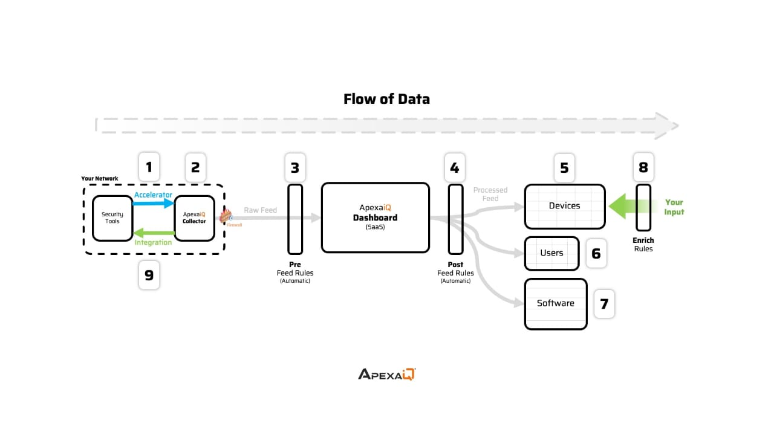

**Fig. 4.1: Working of ApexaiQ**

**Benefits of Agentless Design**

* **Faster Implementation:** No time-consuming agent deployment on every endpoint.
* **Reduced IT Overhead:** Avoids CPU, memory, and storage usage on end-user devices.
* **Broader Compatibility:** Supports a wide variety of devices, operating systems, and network environments without installation barriers.
* **Scalability:** Easily expands to new devices and environments without additional rollout effort.
* **Lower Security Risk:** Eliminates the need to manage or secure additional endpoint software.
* **Centralized Data Gathering:** Leverages APIs, CMDBs, vulnerability scanners, and patch management tools to pull complete asset data from existing sources.

**5. Cybersecurity – A Comprehensive Review**

Cybersecurity is the practice of protecting computer systems, networks, and data from unauthorized access, cyberattacks, and digital threats. It combines technology, processes, and human awareness to defend against malicious activities such as malware, phishing, ransomware, and data breaches.

**Core Objectives**

1. **Protect Systems and Data** – Prevent unauthorized use, damage, or theft of digital assets.
2. **Mitigate Cyber Threats** – Identify, assess, and respond to potential attacks.
3. **Ensure Business Continuity** – Minimize disruption and safeguard critical services.
4. **Build a Security Culture** – Foster awareness and safe practices among users.
5. **Adapt to Emerging Threats** – Continuously evolve defences against new attack methods.

**Importance of Cybersecurity**

* **Safeguards Personal & Financial Information** – Prevents identity theft and fraud.
* **Maintains Operational Stability** – Reduces downtime and prevents reputational damage.
* **Protects Critical Infrastructure** – Defends power grids, healthcare systems, and transport networks.
* **Enables Safe Innovation** – Supports adoption of cloud computing, AI, and IoT.

**Common Cyber Threats & Solutions**

Table 5.1 shows the common cyber threats and their solutions along with their descriptions.

**Table 5.1: Common Cyber Threats and Solutions**

|  |  |  |
| --- | --- | --- |
| **Threat** | **Description** | **Prevention / Solution** |
| Malware | Viruses, worms, ransomware, spyware designed to harm systems or steal data. | Antivirus/anti-malware tools (e.g., Windows Defender, Malwarebytes), regular updates. |
| Phishing | Fake communications to trick users into revealing sensitive data. | Spam filters, phishing awareness training. |
| Password Attacks | Cracking or stealing login credentials. | Strong, complex passwords, MFA, password managers. |
| DDoS | Overwhelming a network to make it unavailable. | Services like Cloudflare, AWS Shield. |
| Man-in-the-Middle (MITM) | Intercepting and altering communications between two parties. | Encryption (SSL/TLS), secure Wi-Fi. |
| Drive-by Downloads | Automatic malware downloads from compromised websites. | Keep software updated, remove outdated components. |
| Malvertising | Malicious ads that install malware. | Ad blockers, safe browsing practices. |
| Rogue Software | Fake security tools that scam users. | Avoid suspicious downloads, verify software sources. |

**Advanced Security Practices**

* **Risk Management & Vulnerability Testing** – Regular audits, penetration testing.
* **Encryption Protocols** – SSL/TLS, end-to-end encryption for secure communication.
* **Incident Response Plans** – Preparedness for threats like ransomware.
* **Security Information & Event Management (SIEM)** – Real-time monitoring and threat detection.
* **Compliance with Standards** – GDPR, HIPAA, ISO 27001.
* **AI & Machine Learning in Security** – Detect anomalies, predict threats.
* **Zero Trust Model** – Verify every access request, trust no device/user by default.

**Key Takeaway**

Cybersecurity is an ongoing process, not a one-time solution. With the rapid adoption of cloud services, IoT devices, and remote work, organizations must adopt layered security measures, continuous monitoring, and user awareness training to stay protected in an ever-evolving digital threat landscape.

**6. Key Concepts**

**6.1 ApexaiQ Score**

**Purpose**

The ApexaiQ Score is a risk rating system designed to assess the security and robustness of an organization’s IT environment. It helps in decisive infrastructure and cybersecurity planning by providing a measurable benchmark. An example of ApexaiQ Score is shown in the Fig. 6.1.

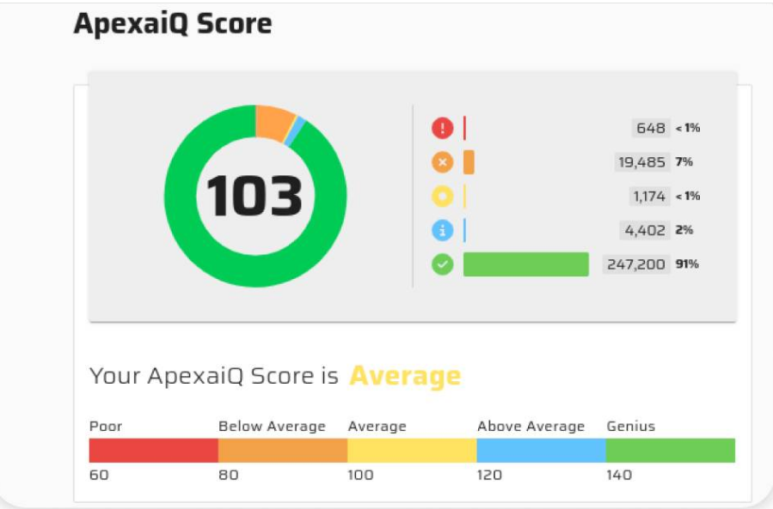

**Fig. 6.1: Example showing ApexaiQ Score**

**Score Range**

* **Minimum:** 60 (Poor)
* **Maximum:** 160 (Genius)
* **Interpretation:** A higher score reflects a more secure IT environment with **lower** potential risks.

**Calculation Criteria**

The score is determined by evaluating:

1. **Vulnerabilities** – Security flaws or weaknesses that can be exploited.
2. **Obsolescence** – The presence of outdated hardware or software.
3. **Compliance Gaps** – Failures in meeting security regulations and industry standards.
4. **Maintenance Issues** – Pending or unresolved IT asset maintenance tasks.

**Key Insight**

A high ApexaiQ Score indicates better IT hygiene, improved resilience against cyber threats, and reduced security risks.

**6.2 IT Asset Management**

**Definition**

IT Asset Management (ITAM) is the systematic process of tracking, managing, and optimizing an organization’s IT assets throughout their entire lifecycle — from procurement to disposal.

**Purpose**

* Ensure visibility and control over all IT assets.
* Optimize usage and cost efficiency.
* Reduce security risks by keeping systems updated and compliant.

**Key Components**

1. **Asset Inventory** – Maintaining a complete list of all hardware, software, and virtual assets.
2. **Lifecycle Management** – Tracking each asset from acquisition to retirement.
3. **Compliance Management** – Ensuring software licenses and IT policies are followed.
4. **Cost Optimization** – Avoiding unnecessary purchases and ensuring maximum ROI from existing assets.

**Benefits**

* Improves budgeting and forecasting for IT expenditures.
* Enhances security posture by identifying outdated or unsupported assets.
* Supports strategic decision-making with accurate asset data.

**6.3 Vulnerabilities**

**Definition**

A vulnerability is a weakness or flaw in an IT system, application, or process that could be exploited by a threat actor to gain unauthorized access, disrupt operations, or compromise data.

**Types of Vulnerabilities**

1. **Software Vulnerabilities** – Bugs, coding errors, or outdated versions in applications and operating systems.
2. **Configuration Vulnerabilities** – Improperly configured systems, firewalls, or network settings.
3. **Hardware Vulnerabilities** – Security flaws in physical devices such as routers, servers, or IoT devices.
4. **Human-related Vulnerabilities** – Weak passwords, phishing susceptibility, or lack of security awareness.

**Impact**

* Data breaches and loss of sensitive information.
* Service outages or degraded system performance.
* Legal and regulatory non-compliance penalties.
* Financial losses and reputational damage.

**Mitigation Strategies**

* Regular patching and updates to fix known security flaws.
* Vulnerability scanning and penetration testing to detect issues early.
* Secure configuration of systems and devices.
* User training to reduce human errors and phishing risks.

**6.4 Obsolescence**

Obsolescence in IT refers to the state where hardware, software, or technology becomes outdated and is no longer supported, efficient, or secure. Obsolete assets can expose an organization to operational inefficiencies, compatibility issues, and increased security risks.

**Types of Obsolescence**

1. **Hardware Obsolescence** – Servers, computers, or networking devices that are beyond their service life.
2. **Software Obsolescence** – Applications or operating systems that no longer receive updates or patches.
3. **Technology Obsolescence** – Systems rendered ineffective due to advancements in newer technologies.
4. **Process Obsolescence** – Outdated operational methods that no longer align with industry best practices.

**Impact**

* Increased vulnerability to security breaches due to lack of vendor support.
* Reduced performance and operational inefficiencies.
* Incompatibility with newer systems, applications, and tools.
* Higher maintenance and replacement costs.

**Mitigation Strategies**

* Regular IT asset lifecycle management to track hardware and software age.
* Planned upgrades and replacements to maintain operational efficiency.
* Cloud adoption for scalability and up-to-date software access.
* Vendor monitoring to anticipate and prepare for end-of-support announcements.

**6.5 Compliance**

**Definition**

Compliance in an IT or business context means following the rules, standards, and regulations that apply to your industry, organization, or region. It’s making sure your systems, processes, and data handling meet all legal, security, and policy requirements — so you don’t break laws, lose certifications, or face penalties.

**Types of compliance in IT:**

1. **Regulatory compliance** → Laws and government regulations.
   * Examples: GDPR (data privacy in the EU), HIPAA (health data in the US), PCI-DSS (payment card security).
2. **Industry standards** → Best-practice frameworks.
   * Examples: ISO 27001 (information security), NIST standards.
3. **Internal compliance** → Company’s own policies and guidelines.
   * Example: Ensuring employees use only approved software and secure passwords.

**Common Areas of Compliance Gaps**

1. **Data Protection** – Not meeting requirements under laws such as GDPR, HIPAA, or local data privacy regulations.
2. **Security Standards** – Failure to comply with frameworks like ISO 27001, NIST, or PCI-DSS.
3. **Licensing Compliance** – Use of unlicensed or improperly licensed software.
4. **Operational Procedures** – Lack of documented security policies, access controls, or audit trails.

**Impact**

* Legal penalties, fines, and lawsuits.
* Damage to brand reputation and loss of customer trust.
* Increased risk of cyberattacks due to weak controls.
* Operational disruptions during audits or enforcement actions.

**Mitigation Strategies**

* Regular compliance audits to identify and close gaps.
* Training and awareness programs for employees on regulatory requirements.
* Policy enforcement through technical controls and monitoring.
* Collaboration with compliance officers to align IT operations with regulations.

**6.6 Maintenance**

**Definition**

Maintenance in an IT context means the ongoing work required to keep systems, software, and hardware running smoothly, securely, and efficiently.

**Main types of IT maintenance:**

1. **Preventive maintenance**
   * Proactive steps to avoid problems before they happen.
   * Examples: installing updates, replacing aging hardware, cleaning servers, testing backups.
2. **Corrective maintenance**
   * Fixing something that’s already broken or malfunctioning.
   * Examples: repairing a crashed server, patching a security flaw, restoring corrupted data.
3. **Adaptive maintenance**
   * Adjusting systems to work in new environments or with new requirements.
   * Examples: updating software to be compatible with a new OS, moving applications to the cloud.
4. **Perfective maintenance**
   * Improving performance or adding enhancements even if there’s no failure.
   * Examples: optimizing code, upgrading network speed, adding new features.

**Common Causes**

1. **Delayed Updates & Patching** – Failure to install security patches or software updates in time.
2. **Neglected Hardware Servicing** – Lack of physical maintenance for servers, workstations, or networking equipment.
3. **Configuration Drift** – Systems gradually moving away from standard configurations due to unmanaged changes.
4. **Expired Support Contracts** – Using equipment or software without vendor support.

**Impact**

* Increased cyber risk due to unpatched vulnerabilities.
* Hardware failures and unexpected downtime.
* Higher operational costs from emergency repairs.
* Reduced system performance and reliability.

**Mitigation Strategies**

* Implement preventive maintenance schedules for both hardware and software.
* Automate patch management to ensure timely updates.
* Monitor asset health through IT management tools.
* Maintain vendor support agreements for critical systems.

**6.7 End of Life, End of Support, End of Maintenance**

**1. End of Life (EOL)**

* **Meaning**: The product is no longer being sold or developed by the vendor.
* **Impact**: You can still use it, but no new features or major updates will be released.

**2. End of Support (EOS)**

* **Meaning**: The vendor stops providing technical support and security updates for the product.
* **Impact**: Using it becomes risky because security vulnerabilities won’t be patched.

**3. End of Maintenance (EOM)**

* **Meaning**: The vendor stops releasing maintenance updates, bug fixes, or patches — but may still offer limited paid support.
* **Impact**: You won’t get performance improvements or bug fixes, but in rare cases, emergency patches might still be available under special contracts.

**6.8 Asset Hygiene**

Asset hygiene means keeping your organization’s IT assets — hardware, software, cloud resources — clean, secure, up-to-date, and properly managed throughout their lifecycle. Good asset hygiene prevents security risks, downtime, and waste in IT systems.

**Key practices for good asset hygiene:**

* **Accurate inventory** → Knowing exactly what devices, software, and cloud accounts you have.
* **Regular updates & patches** → Keeping systems protected from vulnerabilities.
* **Removal of unused/unauthorized assets** → Preventing “shadow IT” and license waste.
* **Compliance checks** → Ensuring assets meet security and regulatory requirements.
* **Lifecycle management** → Retiring or replacing assets before they become obsolete.

**6.9 Crown Jewel**

In IT and cybersecurity, crown jewel refers to the most valuable and critical assets of an organization — the ones that, if stolen, damaged, or leaked, would cause the greatest harm to the business.

**Why they matter:**

* **Top priority for protection** → Security strategies often start by identifying crown jewels so resources are focused where they matter most.
* **High-value target for attackers** → Hackers will often aim for these first.
* **Business impact** → Losing them could mean financial loss, reputation damage, or even business shutdown.

**6.10 Inventory**

In IT, inventory means the complete, up-to-date list of all technology assets your organization owns or uses — both physical and digital.

**What’s included in an IT inventory:**

* **Hardware** → Laptops, servers, network devices, mobile devices, IoT equipment.
* **Software** → Installed programs, operating systems, licenses, SaaS subscriptions.
* **Cloud resources** → Virtual machines, storage buckets, databases.
* **Peripheral assets** → Printers, scanners, monitors.

**Why inventory matters:**

* **Visibility** → You know exactly what assets you have and where they are.
* **Security** → You can track and protect all devices and applications.
* **Compliance** → Proof for audits that you manage assets properly.
* **Cost control** → Prevents overbuying licenses or letting unused hardware sit idle.

**6.11 National Vulnerability Database (NVD)**

A public, U.S. government-managed database that contains information about known cybersecurity vulnerabilities.

* Managed by NIST (National Institute of Standards and Technology).
* Based on vulnerability reports from sources like CVE (Common Vulnerabilities and Exposures).

**What it contains:**

* **Details** → Description of the vulnerability, affected products, and possible impact.
* **Severity rating** → Uses the CVSS (Common Vulnerability Scoring System) to rate risk (e.g., Low, Medium, High, Critical).
* **References** → Links to official advisories, patches, or workarounds.

**Why it matters:**

* Security teams and tools use NVD to track, assess, and remediate vulnerabilities.
* Many automated scanners pull vulnerability data directly from the NVD.

**6.12 Patch Management**

Patch management is the process of acquiring, testing, and applying software updates (patches) to fix bugs, close security vulnerabilities, and improve performance in your IT systems. A patch is a piece of code released by a software vendor to fix a specific issue — often a security flaw, compatibility problem, or stability bug. It can also introduce small feature improvements.

**Steps in patch management:**

1. **Identify** → Detect which systems or software need updates.
2. **Acquire** → Download the official patch from the vendor.
3. **Test** → Check the patch in a safe environment to ensure it doesn’t break anything.
4. **Deploy** → Apply it to production systems.
5. **Verify** → Confirm it’s successfully installed and working.
6. **Document** → Keep records for compliance and audits.

**6.13 Data Breaches**

A data breach is when sensitive, confidential, or protected data is accessed, stolen, or exposed without authorization.

**What counts as a data breach**

* **External attack** → Hackers break into a system and steal customer data.
* **Insider threat** → An employee intentionally or accidentally leaks data.
* **Accidental exposure** → Misconfigured cloud storage makes data public.

**Causes**

* Unpatched vulnerabilities
* Weak passwords or poor authentication
* Phishing attacks
* Misconfigured servers or databases
* Lost or stolen devices

**Consequences**

* **For individuals** → Identity theft, fraud.
* **For organizations** → Financial loss, reputational damage, legal penalties, loss of customer trust.

**6.14 Managed Service Provider (MSP)**

A company that manages IT services for other businesses on a subscription or contract basis. They handle things like:

* Monitoring and maintaining networks
* Managing security and backups
* Providing helpdesk support
* Updating and patching systems

**6.15 Device Types**

Categories of hardware assets in an IT environment.

Examples include:

* **Endpoints** → Laptops, desktops, mobile phones, tablets.
* **Servers** → Physical or virtual machines hosting applications or databases.
* **Network devices** → Routers, switches, firewalls.
* **IoT devices** → Smart sensors, cameras, connected machinery.
* **Peripheral devices** → Printers, scanners, monitors.

In asset management, device types help with classification, tracking, and applying specific policies.

**6.16 True SaaS**

A pure Software-as-a-Service model where:

* The application is fully hosted and managed by the provider in the cloud.
* Customers access it via a browser or API — no installation or heavy setup required.
* All customers use the same codebase (multi-tenant architecture).
* Updates, scaling, and maintenance happen automatically without customer intervention.

**6.17 Inbound/Outbound Integration**

**Inbound integration**

* Data flows into your system from an external source.
* Your system receives data from another platform, API, or database.

**Outbound integration**

* Data flows out of your system to an external destination.
* Your system sends data to another platform, API, or service.

**6.18 Compliance Standards**

Compliance standards are formal rules, frameworks, or guidelines that organizations must follow to meet legal, regulatory, or industry-specific requirements — especially for security, privacy, and operational practices.

**Why they exist**

* Protect sensitive data
* Ensure business processes are reliable
* Maintain trust between organizations and customers
* Avoid legal and financial penalties

**Common compliance standards in IT & security:**

**Data Protection & Privacy**

* **GDPR** (General Data Protection Regulation) → EU privacy law protecting personal data.
* **CCPA** (California Consumer Privacy Act) → U.S. privacy law for California residents.

**Security Frameworks**

* **ISO/IEC 27001** → International standard for information security management systems.
* **NIST Cybersecurity Framework** → U.S. guidelines for managing cybersecurity risks.

**Industry-Specific**

* **PCI-DSS** (Payment Card Industry Data Security Standard) → Required for companies handling credit cards.
* **HIPAA** (Health Insurance Portability and Accountability Act) → U.S. standard for healthcare data security and privacy.
* **SOX** (Sarbanes–Oxley Act) → U.S. law for financial reporting and data accuracy.

**Cloud & Vendor Security**

* **SOC 2** (System and Organization Controls) → Verifies how a company manages customer data securely.
* **FedRAMP** → Security standard for U.S. federal government cloud services.

**6.19 Perimeter**

In IT and cybersecurity, perimeter refers to the boundary that separates an organization’s internal network and systems from the outside world (usually the internet).

Controlled by perimeter defences like:

* Firewalls
* Intrusion prevention systems (IPS)
* Network gateways

**Goal:** Stop unauthorized traffic from entering and sensitive data from leaving.

**6.20 ROI (Return on Investment), KPI (Key Performance Indicators)**

**Return on Investment:**

A financial metric that measures how much profit or benefits you get compared to how much you invested.

**Formula:**

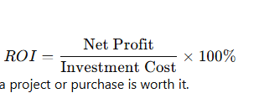

**Why it matters**: Helps decide if a project or purchase is worth it.

**Key Performance Indicators:**

Specific, measurable metrics used to track how well a business, project, or process is performing.

KPIs help you see if you’re meeting goals.

**6.21 Auto-remediation**

The process where software automatically detects problems (like vulnerabilities or misconfigurations) and fixes them without human intervention.

**6.22 Network Protocols**

Network protocols are like the rules and languages computers use to communicate over a network. They define how data is formatted, transmitted, received, and acknowledged between devices.

**Why protocols matter**

Without shared protocols, devices wouldn’t understand each other — it’s like people trying to talk in different languages without a translator.

**Common network protocols**

1. **HTTP / HTTPS**
   * HyperText Transfer Protocol (Secure)
   * Used for web browsing and transferring web pages securely (HTTPS adds encryption).
2. **TCP / IP**
   * Transmission Control Protocol / Internet Protocol
   * The core protocols of the internet, responsible for breaking data into packets, addressing, routing, and reliable delivery.
3. **FTP**
   * File Transfer Protocol
   * For transferring files between computers.
4. **SMTP / IMAP / POP3**
   * Email protocols:
     + SMTP sends emails
     + IMAP and POP3 receive emails.
5. **DNS**
   * Domain Name System
   * Translates human-readable domain names (like google.com) into IP addresses.
6. **SNMP**
   * Simple Network Management Protocol
   * Used for monitoring and managing network devices.
7. **SSH**
   * Secure Shell
   * Provides secure remote login and command execution.

**6.23 Due-diligence**

Due diligence means carefully investigating and evaluating something before making a decision or taking action — to ensure you understand the risks, benefits, and details.

**In IT and business contexts**

* Before buying software, you do due diligence by checking reviews, security features, compliance, and vendor reputation.
* Before a merger or acquisition, companies perform due diligence to assess IT assets, risks, contracts, and liabilities.
* In cybersecurity, due diligence involves regularly auditing systems, patching vulnerabilities, and ensuring policies are followed.

**Why it matters**

* Helps avoid surprises and costly mistakes.
* Builds trust with stakeholders.
* Ensures legal and regulatory requirements are met.

**6.24 SOAR (Security Orchestration, Automation, and Response)**

**Security Orchestration**

* Integrates and connects multiple security tools and systems (like firewalls, SIEMs, antivirus, ticketing).
* Creates a unified workflow so tools “talk” and work together seamlessly.

**Automation**

* Automatically performs repetitive or routine security tasks without manual effort.
* Examples: scanning for vulnerabilities, collecting logs, applying patches, blocking IP addresses.

**Response**

* Helps security teams quickly analyse threats and take action (like isolating infected machines, sending alerts, or creating tickets).
* Supports faster incident response with guided workflows.

**6.25 Role of ITAM in Zero Trust Security Models**

**What is Zero Trust?**

* A security approach where no user or device is automatically trusted, even inside the network perimeter.
* Every access request is verified continuously before being granted.

**Role of ITAM in Zero Trust:**

1. **Complete Visibility of Assets**
   * Zero Trust needs to know every device, software, and user accessing the network.
   * ITAM provides a detailed, up-to-date inventory so nothing is invisible or unmanaged.
2. **Device and Software Posture**
   * ITAM tracks if devices are patched, compliant, and secure before access is allowed.
   * This supports the “verify before trust” principle.
3. **Identity and Access Management (IAM) Integration**
   * ITAM data feeds into IAM systems to correlate devices and users.
   * Helps enforce least privilege access by ensuring only approved assets get certain permissions.
4. **Continuous Monitoring and Risk Assessment**
   * ITAM combined with real-time monitoring flags risky or compromised assets.
   * Zero Trust uses this info to deny or restrict access dynamically.
5. **Support for Micro-Segmentation**
   * Knowing asset types and roles allows Zero Trust to segment the network and control communication between devices.

**6.26 Cyber Asset Attack Surface Management (CAASM)**

Cyber Asset Attack Surface Management (CAASM) is a security practice and technology focused on discovering, monitoring, and managing all the digital assets of an organization to reduce their exposure to cyberattacks.

**Breaking it down:**

* **Cyber Assets**: All hardware, software, cloud services, IoT devices, accounts, and anything connected to your network or digital environment.
* **Attack Surface**: All the points where an attacker could potentially try to enter or exploit your systems — including vulnerable devices, exposed software, open ports, misconfigurations, or weak credentials.
* **Management**: Continuously identifying, assessing, and prioritizing risks across your entire digital footprint to shrink and secure the attack surface.

**Why CAASM matters:**

* Organizations often don’t have a complete or accurate inventory of their cyber assets, especially as environments become complex with cloud, remote work, and IoT.
* CAASM tools provide a centralized, real-time view of assets by aggregating data from various sources like ITAM, vulnerability scanners, cloud platforms, and endpoint management.
* Helps security teams prioritize remediation efforts by highlighting the riskiest or most critical exposed assets.

**How CAASM fits in the security ecosystem:**

* Complements IT Asset Management (ITAM) by focusing specifically on security risks related to assets.
* Supports vulnerability management, incident response, and risk assessment by providing actionable asset visibility.

**Conclusion**

This documentation provides a structured reference to ApexaiQ’s core functions, differentiators, and the key concepts relevant to IT asset intelligence and cybersecurity. By outlining the platform’s role in addressing industry challenges, comparing it with competitor solutions, and detailing associated security practices, this resource lays the foundation for deeper technical and strategic exploration in subsequent internship tasks.

The detailed breakdown of IT Asset Management principles, cybersecurity practices, and platform architecture not only clarifies ApexaiQ’s operational strengths but also highlights its relevance in a rapidly evolving digital landscape. The inclusion of competitor case studies further contextualizes the company’s positioning, enabling a clearer understanding of its unique agentless approach and emphasis on real-time risk scoring.

This compilation will serve as an ongoing reference for both technical and strategic discussions during the internship, ensuring that subsequent work builds on a well-informed perspective. It also reinforces the importance of maintaining comprehensive domain knowledge as a prerequisite for contributing effectively to product development, client engagement, and industry-focused problem-solving.

***